**A REPORT**

**ON**

**Flame Intensity Classification Using Infrared Image Processing and Neural Networks**

## **By**

**Name of the students** **Registration No.**

1) Sai Charan Teja Janaki AP21110011314

2) Khyathi Devi Kotipalli AP21110011327

**Prepared in the partial fulfillment of the**

Digital Image Processing Course

(CSE 314)

Sec S 7th Sem 2024



|  |
| --- |
|  |

**AT**

**SRM University, AP**

**Neerukonda, Mangalagiri, Guntur**

**Andhra Pradesh – 522 240**

**Under the Guidance of Ms.Tonmoya Sarmah**

**[November 2024]**

# Table of Contents

Table of Contents 2

Abstract 3

1. Introduction 4

1.1 Overview 4

1.2 Background 5

1.3 Problem Statement 5

2. Objectives 6

3. Workflow 7

4. Methodology 8

5. Results 13

6. Concluding Remarks 15

7. Future Works 16

**ABSTRACT**

Infrared imaging has become a vital tool for analyzing heat patterns and detecting high-temperature regions, especially in industrial and safety-critical environments. Infrared flame datasets provide a non-invasive method to study temperature variations, offering valuable insights for applications such as fire detection, hazard prevention, and thermal monitoring. This study focuses on classifying high-temperature regions in infrared flame images by leveraging grayscale transformation and neural networks.

The methodology involves preprocessing infrared flame images by converting them to grayscale and analyzing pixel intensities to identify regions with the highest temperature. Neural networks are employed to classify images into distinct categories based on temperature thresholds, distinguishing high-temperature regions from others. Data augmentation techniques enhance model performance by addressing class imbalance, and a systematic training and validation process ensures reliable classification results.

The proposed approach demonstrates the potential of combining infrared imaging and machine learning to accurately identify and classify high-temperature regions. This research contributes to advancements in thermal monitoring systems, paving the way for safer and more efficient operations in industrial and environmental contexts.

1. **Introduction**

In recent years, infrared imaging has emerged as a pivotal tool for studying heat distribution and temperature anomalies across various domains, including industrial safety, environmental monitoring, and scientific research. Flames, a primary source of thermal radiation, emit energy that can be captured through infrared imaging to provide insights into their intensity and behavior. Detecting and analyzing high-temperature regions in infrared flame images is critical for applications such as fire safety, combustion efficiency analysis, and early hazard detection.

High-temperature regions in flames often indicate areas of increased energy release, making them vital for monitoring and intervention. Infrared imaging offers a non-invasive and precise method to analyze these regions by leveraging the heat signature emitted. However, manual interpretation of such data can be time-consuming and prone to human error. This necessitates the integration of automated approaches to enhance detection accuracy and consistency.

This research report explores the use of neural networks to classify high-temperature regions in infrared flame datasets. By converting images to grayscale and analyzing pixel intensity distributions, we aim to detect regions of interest that represent the highest temperature areas in the flame. Neural networks are then employed to classify these regions into predefined categories, aiding in rapid and accurate thermal analysis.

**1.1 Overview**

The process of analyzing high-temperature regions in infrared flame images involves several challenges. Flame characteristics can vary significantly based on factors such as combustion material, environmental conditions, and the imaging setup. Additionally, infrared images often include noise and artifacts that can complicate accurate temperature detection. Efficient preprocessing and robust machine learning models are essential to overcome these challenges.

Neural networks, a subset of machine learning, have demonstrated remarkable capabilities in image analysis and classification tasks. Their ability to learn complex patterns in data makes them ideal for identifying and categorizing high-temperature regions in flame images. Data augmentation techniques play a crucial role in enhancing the model's robustness by diversifying the training dataset, thereby improving classification accuracy.

This study combines infrared imaging, grayscale conversion, and neural network-based classification to achieve reliable detection of high-temperature regions. The integration of these techniques offers a scalable solution for applications requiring thermal monitoring and anomaly detection.

**1.2 Background**

Infrared imaging captures the thermal radiation emitted by objects, providing a detailed representation of their temperature distribution. Flames, being dynamic and complex heat sources, generate varying intensities of infrared radiation depending on their temperature and combustion process. The highest temperature regions are often indicative of the most intense reactions within the flame, making their detection critical for safety and efficiency.

Historically, the analysis of flame characteristics was conducted through manual methods, which were limited by their subjectivity and time requirements. The advent of machine learning has revolutionized this process, enabling automated and precise classification of temperature patterns in flame images. Neural networks, in particular, excel at processing high-dimensional data, making them suitable for analyzing infrared flame datasets.

The evolution of imaging technologies and machine learning algorithms has facilitated the development of systems capable of real-time thermal analysis. These systems hold immense potential for applications ranging from industrial safety to environmental monitoring, where detecting high-temperature regions is essential for decision-making.

**1.3** **Problem Statement**

The core challenge of this research lies in accurately classifying high-temperature regions in infrared flame images. Variations in flame characteristics, coupled with noise and artifacts in the images, make manual interpretation unreliable and inefficient. This study aims to address these challenges by developing an automated classification system using neural networks, enhancing the accuracy and efficiency of thermal analysis. By tackling this problem, the research contributes to advancements in thermal monitoring systems, bridging the gap between manual methods and intelligent, data-driven solutions.

1. **Objectives**

* **Accurate Detection of High-Temperature Regions**: Identify and isolate the regions in infrared flame images that exhibit the highest temperatures using grayscale intensity analysis.
* **Efficient Data Processing**: Implement preprocessing techniques such as grayscale conversion, image resizing, and augmentation to ensure robust training of the neural network.
* **Scalable Solution**: Create a scalable workflow that can be applied to other thermal imaging datasets for anomaly detection and classification.
* **Automated Classification**: Develop a neural network model capable of classifying infrared flame images into categories based on their temperature distribution.
* **Enhanced Safety and Monitoring**: Provide a reliable and automated framework to aid applications in industrial safety, hazard monitoring, and combustion efficiency analysis.

1. **Workflow**
2. **Data Collection**: Gather infrared flame images and prepare the dataset.
3. **Data Preprocessing**:

* Resize images to 128x128 for consistency.
* Normalize pixel values to a range of 0 to 1.
* Augment the dataset with transformations like rotations, zooms, and flips.

1. **Model Architecture**: Build a Convolutional Neural Network (CNN) model for classification.
2. **Training**: Train the model on the training dataset and evaluate on the validation set.
3. **Prediction**: Use the trained model to classify new test images.
4. **Evaluation**: Assess the model's performance using accuracy, confusion matrix, and classification report.
5. **Methodology**

**4.1 Data Collection:**

The dataset used in this project consists of infrared flame images, sourced from publicly available thermal imaging datasets specifically designed for combustion and safety analysis.

**4.2 Data Organization:**

The collected dataset was systematically organized for efficient preprocessing and analysis. Using Python libraries, the images were processed from specified directories and categorized into labeled groups based on intensity thresholds.

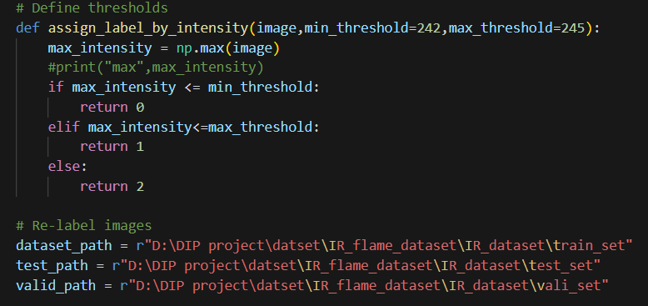

This organized approach ensures a clean and structured dataset for accurate analysis, augmentation, and classification.

**4.3 Preprocessing:**

**Conversion to Grayscale and Resizing:**

Each image was converted to grayscale to simplify the data and focus on intensity variations, which are critical for temperature classification. All images were resized to a uniform dimension of 128x128 pixels to standardize input dimensions for the neural network.

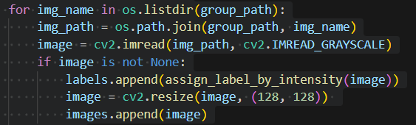

**Data Augmentation:**

To enhance the dataset's diversity and robustness, an augmentation pipeline is established using the ImageDataGenerator.

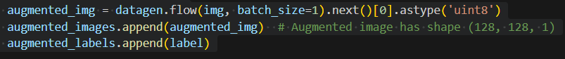

Techniques such as Rotation, Zoom, Horizontal Flip are applied to original audio samples, generating augmented versions of the data.

**Final Dataset:**

After preprocessing, the dataset included:

* **Training data**: Augmented images for balanced class representation.
* **Validation data**: A small, unaltered subset for hyperparameter tuning.
* **Test data**: Unseen images to evaluate model performance.
* 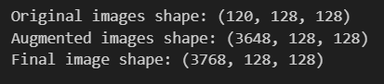

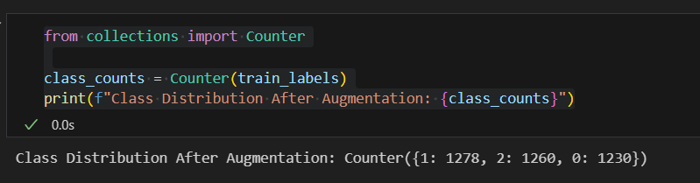

**4.4 Model Architecture:**

The classification model is designed to identify high-temperature regions in infrared flame images by combining spatial and extracted features. The architecture integrates convolutional neural networks (CNNs) for image feature extraction and explicit high-temperature feature inputs.

1. **Define the Image Input**
   * Specify the input layer for images with the required shape (flattened image pixels).
   * 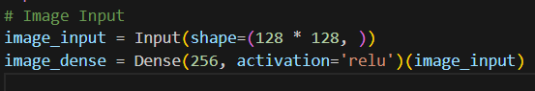Pass this input through a dense layer with 256 neurons and ReLU activation to extract features.
2. **Define the Highlighted Features Input**
   * Specify the input layer for highlighted features with the shape matching the number of features.
   * 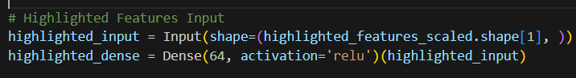Pass this input through a dense layer with 64 neurons and ReLU activation to process these features.
3. **Combine the Two Inputs**
   * Use a concatenation layer to combine the outputs of the image and highlighted feature dense layers.
   * Pass the combined data through another dense layer with 128 neurons and ReLU activation to learn fused features.

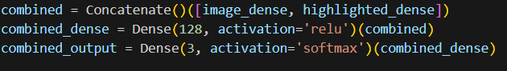

1. **Define the Output Layer**

Add a dense layer with 3 neurons (corresponding to the 3 classes) and softmax activation to output class probabilities.

1. **Create and Compile the Model**
   * Create a Keras model using the inputs (image and highlighted features) and the final output layer.
   * Compile the model with the Adam optimizer, sparse categorical cross-entropy loss (suitable for multi-class classification), and accuracy as the evaluation metric.



1. **Summarize the Model**

Display the architecture to verify the input-output structure and number of parameters.

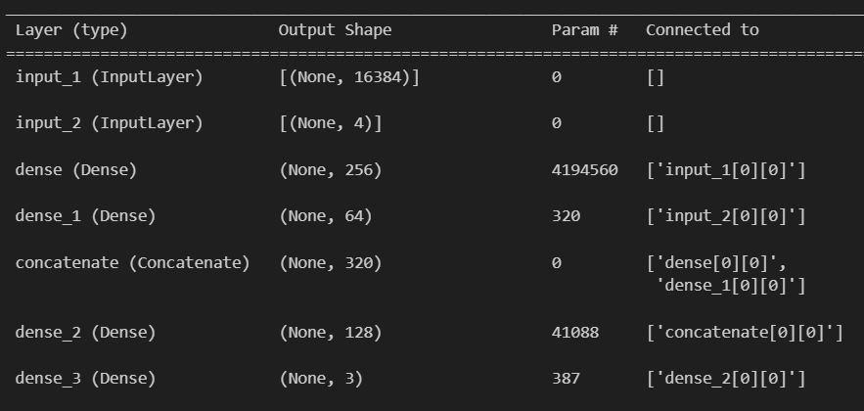

**7. Fit the Model**

The training process uses the EarlyStopping callback to monitor validation loss, stopping if it doesn't improve for 3 epochs while restoring the best weights. The model is trained with two inputs: reshaped image data and highlighted features, across a maximum of 20 epochs with a batch size of 32. Training metrics, including loss and accuracy, are stored in the history object for further evaluation.

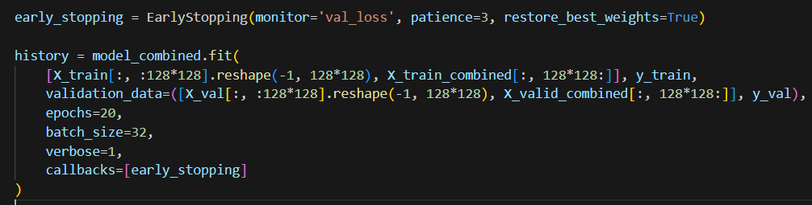

**4.5 Model prediction:**

The model predicts probabilities for each class using test inputs split into image data and highlighted features. The predictions are converted into class labels using np.argmax. These labels can then be evaluated using metrics like accuracy, classification reports, and confusion matrices.

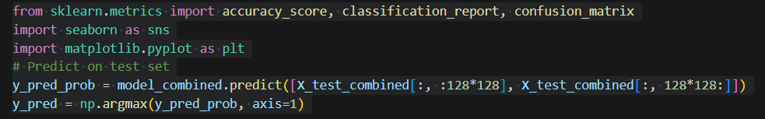

**4.6 Evaluation Metrics:**

* **Accuracy:** Measures the proportion of correct predictions over total predictions.
* **Confusion Matrix:** Provides a detailed breakdown of true positives, true negatives, false positives, and false negatives.
* **Classification Report:** Includes precision, recall, and F1-score for each class.

# 5. Results:

**Accuracy:**

The model achieved an overall classification accuracy of **87.50%** on the test dataset, indicating robust performance in distinguishing between normal, moderate, and high-temperature flame regions.

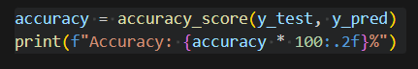

**Classification Report:**

* **Normal**: Precision = 90%, Recall = 91%, F1-Score = 91%
* **Moderate**: Precision = 59%, Recall = 56%, F1-Score = 57%
* **High**: Precision = 100%, Recall = 100%, F1-Score = 100%

These results highlight the model's exceptional capability to classify high-temperature regions accurately while showing room for improvement in moderate classifications.

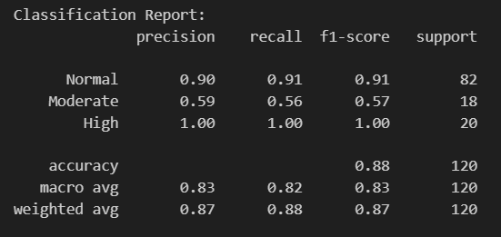

**Confusion Matrix:** The confusion matrix revealed a high number of correct predictions for "Normal" and "High" classes, with some misclassifications between "Moderate" and "Normal" images.

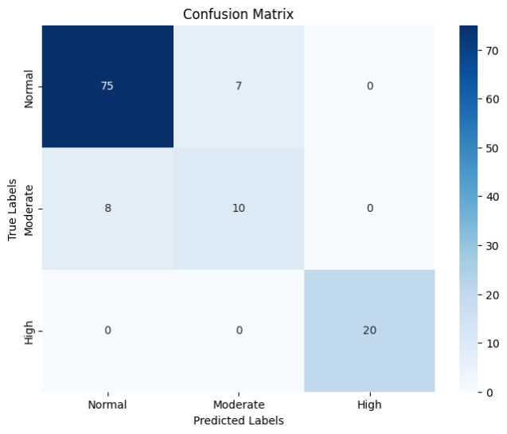

**Training and Validation Metrics:**

* Training Loss decreased steadily across epochs, indicating effective learning.
* Validation Loss and Validation Accuracy demonstrated convergence, confirming the model's generalization ability without overfitting.

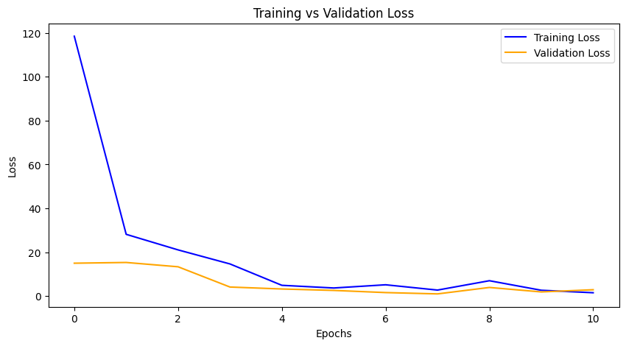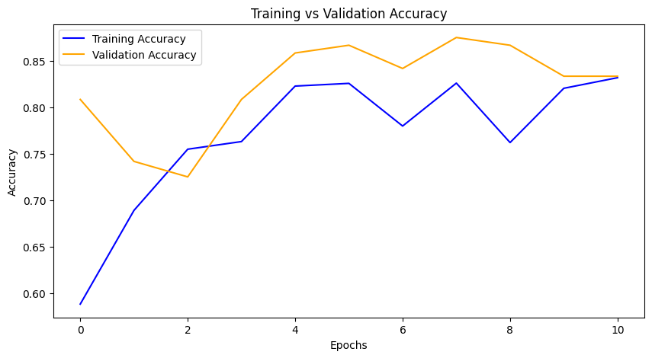

The model effectively leverages image features and extracted high-temperature characteristics, achieving high accuracy, particularly for "Normal" and "High" temperature classifications. However, further optimization is recommended to improve the classification of "Moderate" regions.

**6. Concluding Remarks**

In conclusion, the analysis of infrared flame images for high-temperature region detection and classification using neural networks has showcased the potential of modern machine learning techniques in advancing image-based diagnostics. This study has illuminated the ability of deep learning models to identify and classify regions of varying thermal intensities, contributing to safety-critical applications in industrial and environmental monitoring. By extracting features from grayscale images and applying neural networks, valuable insights into temperature distribution have been achieved, enhancing the understanding of flame behavior.

This research highlights the effectiveness of leveraging convolutional neural networks (CNNs) for image classification tasks. The layered architecture employed demonstrates the power of hierarchical feature extraction, enabling accurate discrimination between normal, moderate, and high-temperature regions. The success of this approach lays the foundation for exploring more sophisticated architectures and optimizations in future studies.

While the current model has performed well, particularly in identifying high-temperature regions, there remains scope for improvement in the classification of moderate-temperature areas. Advancements in feature engineering, data augmentation techniques, and model optimization can further refine performance. By embracing the continuous evolution of machine learning methodologies, this research aims to contribute to robust, automated systems capable of transforming thermal image analysis into actionable insights across various industries.

**7. Future Work**

**Dataset Expansion and Diversity**:  
Expanding the dataset with diverse flame scenarios, varying environmental conditions, and different camera angles can improve model generalizability and robustness.

**Integration of Advanced Feature Extraction**:  
Implementing advanced feature extraction techniques, such as spectral analysis or texture-based features, could provide additional insights into flame characteristics and improve classification accuracy.

**Model Optimization**:  
Exploring deeper neural network architectures like ResNet or transformer-based models can potentially improve performance. Techniques like hyperparameter tuning and transfer learning could also be employed for further optimization.

**Real-Time Implementation**:  
Developing a real-time system for high-temperature region detection and classification using optimized inference pipelines would make this research applicable in industrial and safety-critical environments.

**Cross-Domain Applications**:  
Extending the methodology to other domains, such as wildfire monitoring, industrial furnace diagnostics, or even medical thermal imaging, can broaden the impact of this research.

**Explainability and Visualization**:  
Incorporating model interpretability techniques like Grad-CAM or SHAP can help visualize decision-making processes, ensuring transparency and reliability in high-stakes applications.

**Integration with IoT and Automation Systems**:  
Embedding the classification system into Internet of Things (IoT) frameworks can enable automated decision-making, such as triggering alarms or controlling extinguishing mechanisms based on detected high temperatures.